DOKUMENTACIJA

TEA HOUSE

Nikola Pejic 38/23

Sadrzaj

1. Uvod
   1. Korisceni programski jezici
   2. Opis funkcionalnosti
   3. Template
2. Organizacija
   1. Organizaciona sema
   2. Mapa sajta
   3. Slike stranica i opis funkcionalnosti
3. Kodovi
   1. HTML
   2. Javascript
   3. CSS

1.Uvod

1.1 Korisceni programski jezici

Sajt je napravljen koriscenjem: HTML,CSS,Javascript,Jquery,Bootstrap

Okruzenje: Visual Studio Code

1.2 Funkcionalnosti

Zajdnicko na svim stranama:

* Dinamicko ispisivanje menija
* Back to top button koji nestaje pri vrhu stranice koriscenjem JQuery-a
* Newsletter u footer ima validaciju
* Dinamicko ispisivanje quick links u footeru

“index.html”

* Carousel na pocetku stranice koji se menja na svakih 7 sekundi
* Dinamicki ispis producta
* “Read more” button koji otvara modal sa tekstom
* Dinamicki ispis testimoniala i na taster se menjaju naizmenicno, samo jedan se prikazuje

“store.html”

* Dinamicko ispisivanje 3 produkta na klik tastera, nakon ispisanih 6 produkta iskace poruka da nema vise na stanju

“contact.html”

* Validacije cele forme
* Dinamicki dodata dropdown lista

1.3 Template

* Koriscen je template sa ovog linka:
* <https://htmlcodex.com/demo/?item=2683>

2.Organizacija

2.1 Organizaciona sema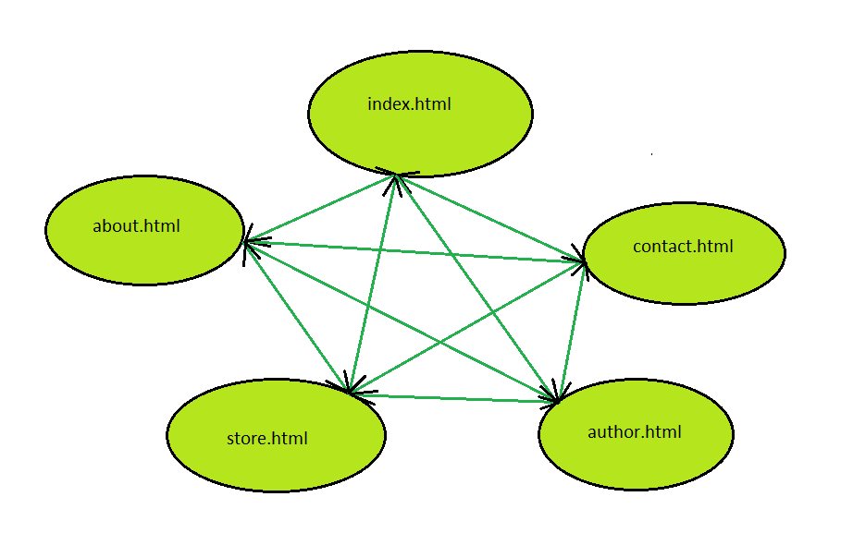

2.2 Mapa sajta

<?xml version="1.0" encoding="UTF-8"?>

<urlset xmlns="http://www.sitemaps.org/schemas/sitemap/0.9">

<url>

<loc>https://ajtemm.github.io/teahouse/</loc>

<lastmod>2024-12-06</lastmod>

<changefreq>weekly</changefreq>

<priority>0.8</priority>

</url>

<url>

<loc>https://ajtemm.github.io/teahouse/about.html</loc>

<lastmod>2024-12-05</lastmod>

<changefreq>monthly</changefreq>

<priority>0.6</priority>

</url>

<url>

<loc>https://ajtemm.github.io/teahouse/about.html</loc>

<lastmod>2024-12-01</lastmod>

<changefreq>monthly</changefreq>

<priority>0.6</priority>

</url>

<url>

<loc>https://ajtemm.github.io/teahouse/store.html</loc>

<lastmod>2024-12-06</lastmod>

<changefreq>daily</changefreq>

<priority>1</priority>

</url>

<url>

<loc>https://ajtemm.github.io/teahouse/contact.html</loc>

<lastmod>2024-12-04</lastmod>

<changefreq>weekly</changefreq>

<priority>0.7</priority>

</url>

<url>

<loc>https://ajtemm.github.io/teahouse/author.html</loc>

<lastmod>2024-11-30</lastmod>

<changefreq>weekly</changefreq>

<priority>0.5</priority>

</url>

</urlset>

2.3

* 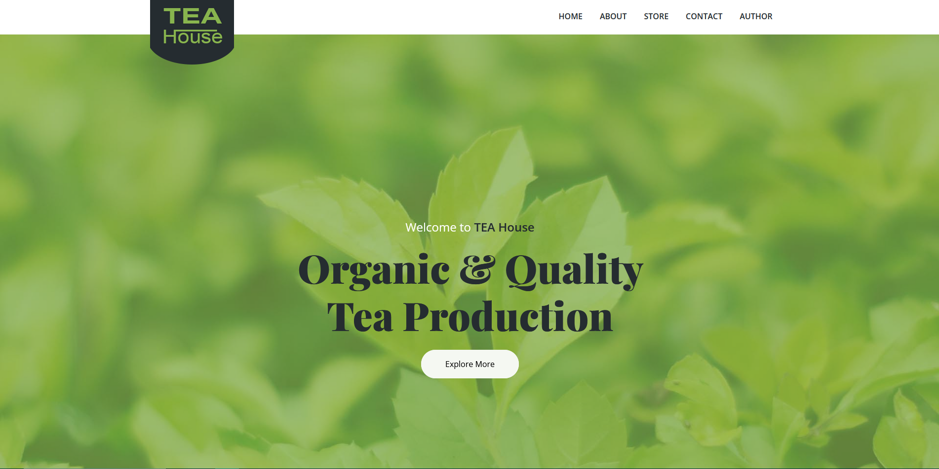
* Dinamicki ispis meni linkova i carousel koji se menja na svakih 7 sekundi kada je mouseOut, a kada je mouseOver onda se ne menja
* 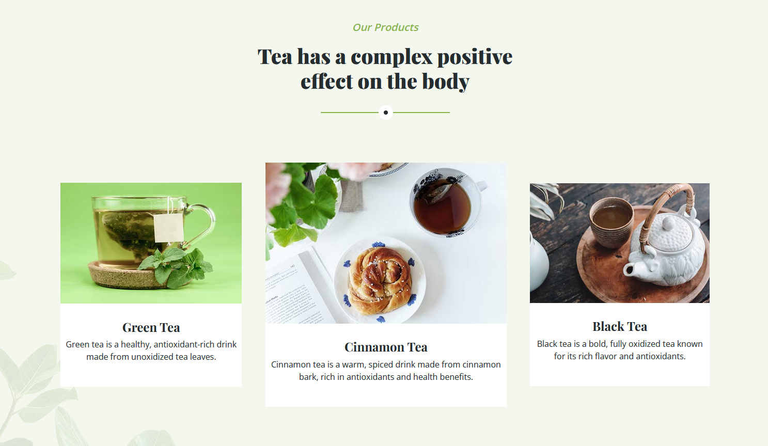
* Dinamicki ispis 3 bloka product pomocu niza u javascriptu
* 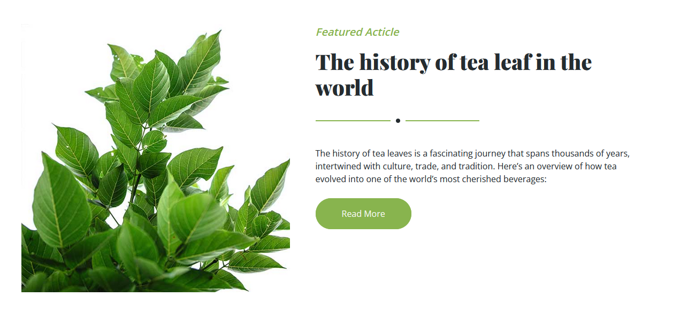
* Klikom na taster “Read More” otvara se modal koji je ispunjen tekstom i ima close button u gornjem levom uglu, a moze se i izaci iz modala klikom sa strane
* 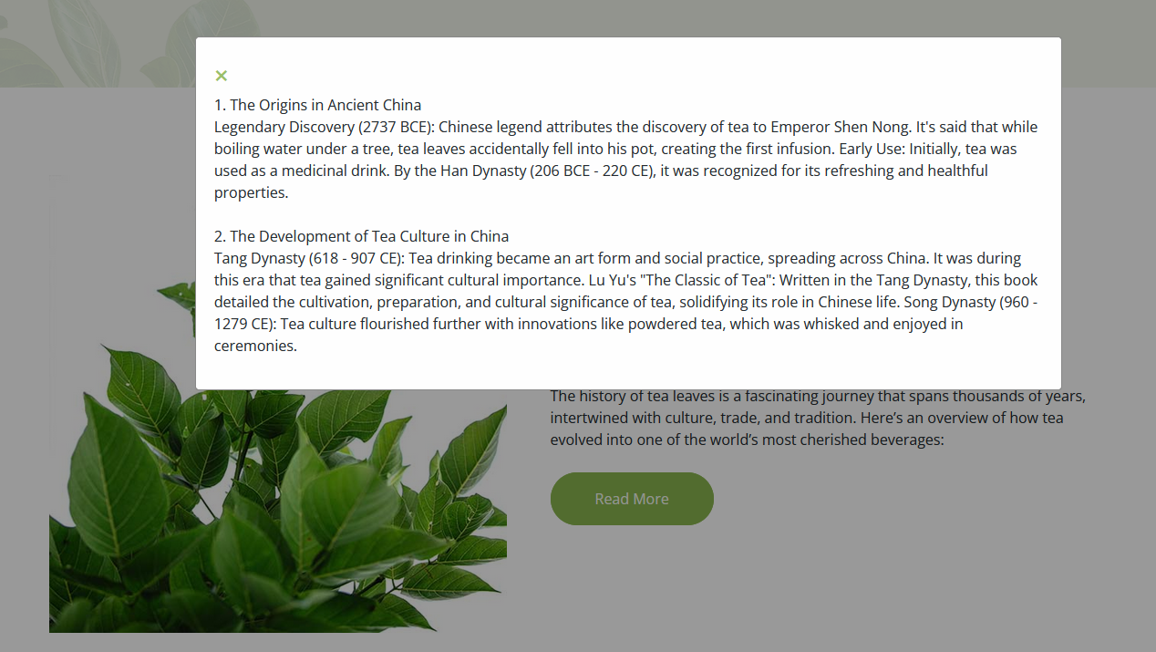
* 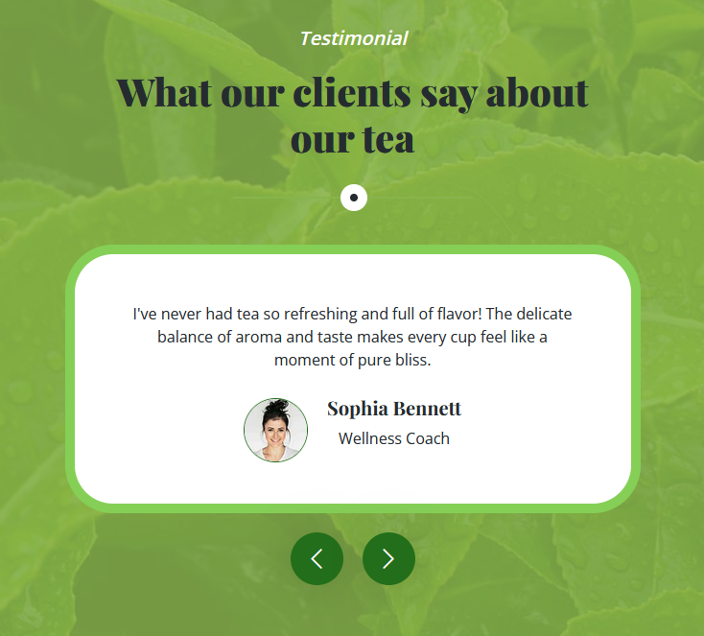
* Dinamicki napravljen niz testimoniala koji se prikazuju klikom na neki od tastera
* 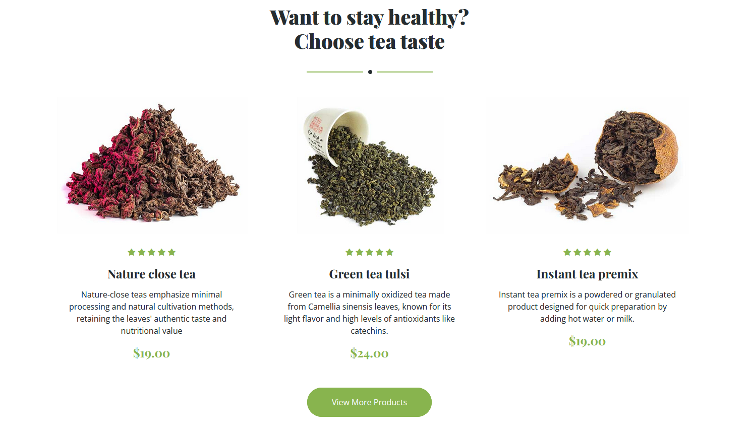
* Klikom na taster “View More Products” Dodaju se nova 3 proizvoda i button se spusta ispod njih, ako se jos jednom klikne na taster pokazace se jos dodatna 3 prozivoda i taster ce nestati a ispisace se tekst
* 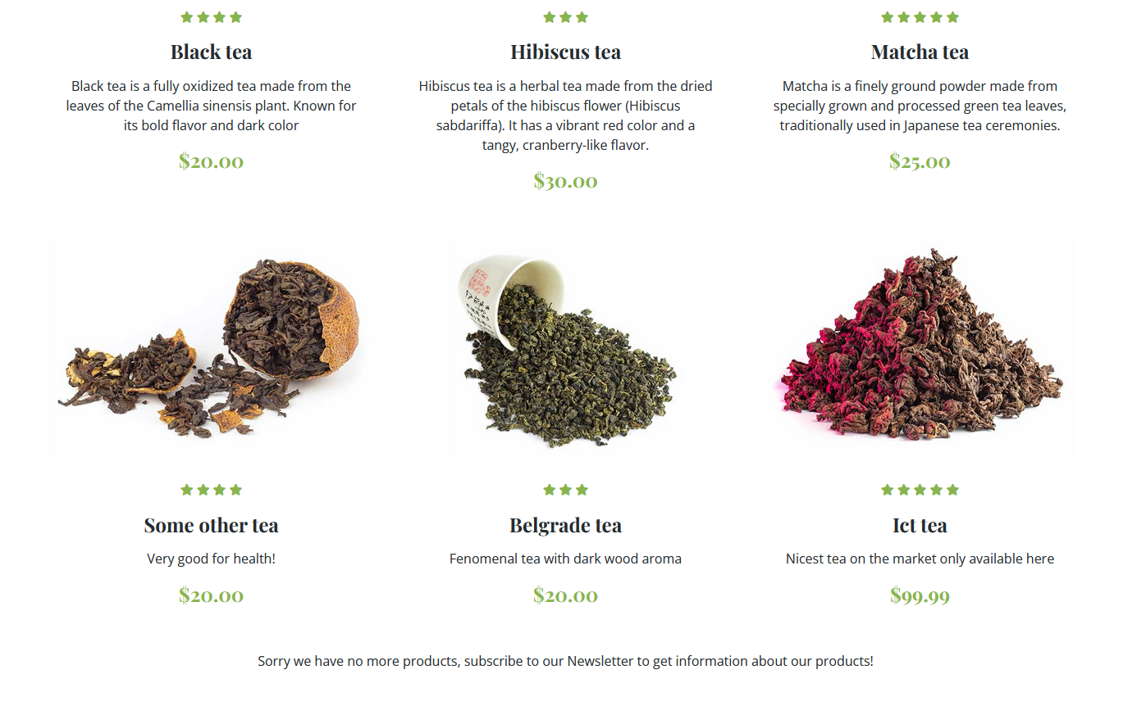
* 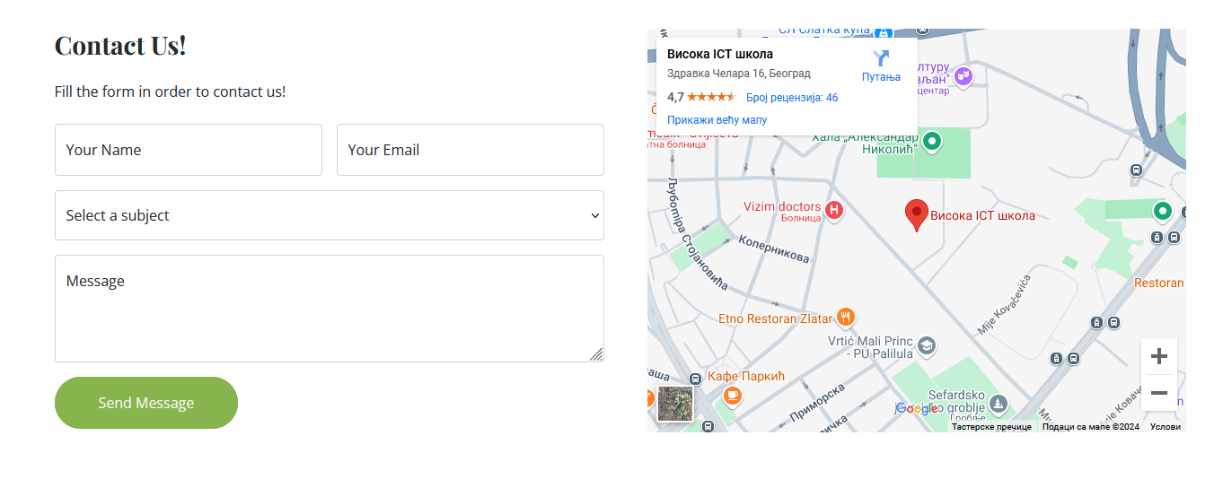
* Odradjena cela validacija forme svi su required , i dodata dropdown lista
* Ovako izgleda kada je forma lose popunjena
* 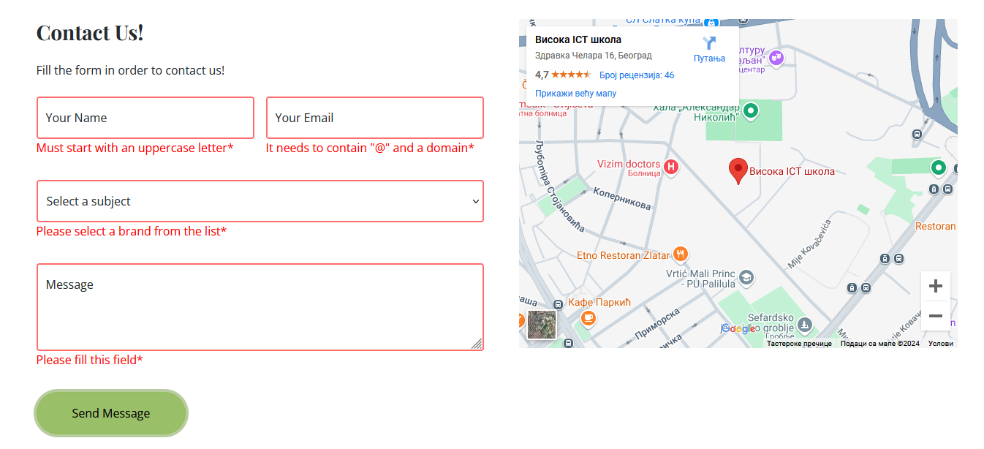
* 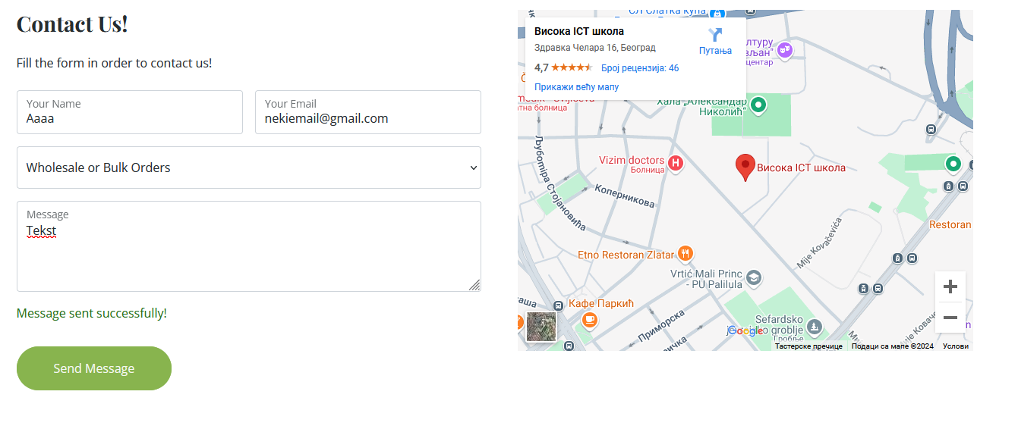
* Kada je dobro popunjena iskoci poruka da je poruka poslata
* 
* Dinamicki ispis Quick Links na svakoj stranici i Newsletter koji ima validaciju

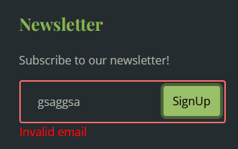

3.Kodovi

3.1 HTML

INDEX.HTML  
  
<!DOCTYPE html>

<html lang="en">

<head>

<meta charset="utf-8">

<title>Tea House - Tea Shop Website Template</title>

<meta content="width=device-width, initial-scale=1.0" name="viewport">

<meta content="" name="keywords">

<meta content="" name="description">

<!-- Favicon -->

<link href="img/favicon.ico" rel="icon">

<!-- Google Web Fonts -->

<link rel="preconnect" href="https://fonts.googleapis.com">

<link rel="preconnect" href="https://fonts.gstatic.com" crossorigin>

<link href="https://fonts.googleapis.com/css2?family=Open+Sans:wght@400;600&family=Playfair+Display:wght@700;900&display=swap" rel="stylesheet">

<!-- Icon Font Stylesheet -->

<link href="https://cdnjs.cloudflare.com/ajax/libs/font-awesome/5.10.0/css/all.min.css" rel="stylesheet">

<link href="https://cdn.jsdelivr.net/npm/bootstrap-icons@1.4.1/font/bootstrap-icons.css" rel="stylesheet">

<!-- Libraries Stylesheet -->

<link href="lib/animate/animate.min.css" rel="stylesheet">

<link href="lib/owlcarousel/assets/owl.carousel.min.css" rel="stylesheet">

<!-- Customized Bootstrap Stylesheet -->

<link href="css/bootstrap.min.css" rel="stylesheet">

<!-- Template Stylesheet -->

<link href="css/style.css" rel="stylesheet"/>

</head>

<body>

<!-- Navbar Start-->

<div class="container-fluid bg-white sticky-top">

<div class="container">

<nav class="navbar navbar-expand-lg bg-white navbar-light py-2 py-lg-0">

<a href="index.html" class="navbar-brand">

<img class="img-fluid" src="img/logo.png" alt="Logo">

</a>

<button type="button" class="navbar-toggler ms-auto me-0" data-bs-toggle="collapse" data-bs-target="#navbarCollapse">

<span class="navbar-toggler-icon"></span>

</button>

<div class="collapse navbar-collapse" id="navbarCollapse">

<div class="navbar-nav ms-auto" id="meni">

<!--

<a href="index.html" class="nav-item nav-link active">Home</a>

<a href="about.html" class="nav-item nav-link">About</a>

<a href="product.html" class="nav-item nav-link">Products</a>

<a href="store.html" class="nav-item nav-link">Store</a>

<div class="nav-item dropdown">

<a href="#" class="nav-link dropdown-toggle" data-bs-toggle="dropdown">Pages</a>

<div class="dropdown-menu bg-light rounded-0 m-0">

<a href="feature.html" class="dropdown-item">Features</a>

<a href="blog.html" class="dropdown-item">Blog Article</a>

<a href="testimonial.html" class="dropdown-item">Testimonial</a>

<a href="404.html" class="dropdown-item">404 Page</a>

</div>

</div>

<a href="contact.html" class="nav-item nav-link">Contact</a>

-->

</div>

</div>

</nav>

</div>

</div>

<!-- Navbar End-->

<!-- Carousel Start -->

<div class="container-fluid px-0 mb-5">

<div id="header-carousel" class="carousel slide carousel-fade" data-bs-ride="carousel">

<div class="carousel-inner">

<div class="carousel-item active">

<img class="w-100" src="img/carousel-1.jpg" alt="Image">

<div class="carousel-caption">

<div class="container">

<div class="row justify-content-center">

<div class="col-lg-7 text-center">

<p class="fs-4 text-white animated zoomIn">Welcome to <strong class="text-dark">TEA House</strong></p>

<h1 class="display-1 text-dark mb-4 animated zoomIn">Organic & Quality Tea Production</h1>

<a href="#explore" class="btn btn-light rounded-pill py-3 px-5 animated zoomIn">Explore More</a>

</div>

</div>

</div>

</div>

</div>

<div class="carousel-item">

<img class="w-100" src="img/carousel-2.jpg" alt="Image">

<div class="carousel-caption">

<div class="container">

<div class="row justify-content-center">

<div class="col-lg-7 text-center">

<p class="fs-4 text-white animated zoomIn">Place with variety of tea <strong class="text-dark">TEA House</strong></p>

<h1 class="display-1 text-dark mb-4 animated zoomIn">Explore our store!</h1>

<a href="store.html" class="btn btn-light rounded-pill py-3 px-5 animated zoomIn">Store</a>

</div>

</div>

</div>

</div>

</div>

</div>

</div>

</div>

<!-- Carousel End -->

<!-- About Start -->

<div class="container-xxl py-5" id="explore">

<div class="container">

<div class="row g-5">

<div class="col-lg-6">

<div class="row g-3">

<div class="col-6 text-end">

<img class="img-fluid bg-white w-100 mb-3 wow fadeIn" data-wow-delay="0.1s" src="img/about-1.jpg" alt="">

<img class="img-fluid bg-white w-50 wow fadeIn" data-wow-delay="0.2s" src="img/about-3.jpg" alt="">

</div>

<div class="col-6">

<img class="img-fluid bg-white w-50 mb-3 wow fadeIn" data-wow-delay="0.3s" src="img/about-4.jpg" alt="">

<img class="img-fluid bg-white w-100 wow fadeIn" data-wow-delay="0.4s" src="img/about-2.jpg" alt="">

</div>

</div>

</div>

<div class="col-lg-6 wow fadeIn" data-wow-delay="0.5s">

<div class="section-title">

<p class="fs-5 fw-medium fst-italic text-primary">About Us</p>

<h1 class="display-6">The success history of TEA House in 25 years</h1>

</div>

<div class="row g-3 mb-4">

<div class="col-sm-4">

<img class="img-fluid bg-white w-100" src="img/about-5.jpg" alt="">

</div>

<div class="col-sm-8">

<h5>Our tea is one of the most popular drinks in the world</h5>

<p class="mb-0">Tea is one of the most widely consumed beverages globally, second only to water. Its popularity stems from its rich history, diverse flavors, and numerous health benefits.</p>

</div>

</div>

<div class="border-top mb-4"></div>

<div class="row g-3">

<div class="col-sm-8">

<h5>Daily use of a cup of tea is good for your health</h5>

<p class="mb-0">Drinking tea daily is not only a comforting ritual but also offers a range of health benefits, thanks to its rich content of antioxidants, vitamins, and other bioactive compounds.</p>

</div>

<div class="col-sm-4">

<img class="img-fluid bg-white w-100" src="img/about-6.jpg" alt="">

</div>

</div>

</div>

</div>

</div>

</div>

<!-- About End -->

<!-- Products Start -->

<div class="container-fluid product py-5 my-5">

<div class="container py-5">

<div class="section-title text-center mx-auto wow fadeInUp" data-wow-delay="0.1s" style="max-width: 500px;">

<p class="fs-5 fw-medium fst-italic text-primary">Our Products</p>

<h1 class="display-6">Tea has a complex positive effect on the body</h1>

</div>

<div id="productsMain1" class="flexi2">

<div id="productsMain2" class="py-5 flexi">

</div>

</div>

</div>

</div>

<!-- Products End -->

<!-- Article Start -->

<div class="container-xxl py-5">

<div class="container">

<div class="row g-5">

<div class="col-lg-5 wow fadeIn" data-wow-delay="0.1s">

<img class="img-fluid" src="img/article.jpg" alt="">

</div>

<div class="col-lg-6 wow fadeIn" data-wow-delay="0.5s">

<div class="section-title">

<p class="fs-5 fw-medium fst-italic text-primary">Featured Acticle</p>

<h1 class="display-6">The history of tea leaf in the world</h1>

</div>

<p class="mb-4">The history of tea leaves is a fascinating journey that spans thousands of years, intertwined with culture, trade, and tradition. Here’s an overview of how tea evolved into one of the world’s most cherished beverages:</p>

<a class="btn btn-primary rounded-pill py-3 px-5" id="batnn">Read More</a>

</div>

</div>

</div>

</div>

<div id="mdl" class="modal">

<!-- Modal content -->

<div class="modal-content">

<span class="close">&times;</span>

<p>1. The Origins in Ancient China <br/>

Legendary Discovery (2737 BCE): Chinese legend attributes the discovery of tea to Emperor Shen Nong. It's said that while boiling water under a tree, tea leaves accidentally fell into his pot, creating the first infusion.

Early Use: Initially, tea was used as a medicinal drink. By the Han Dynasty (206 BCE - 220 CE), it was recognized for its refreshing and healthful properties.

<br/><br/>

2. The Development of Tea Culture in China

<br/>

Tang Dynasty (618 - 907 CE): Tea drinking became an art form and social practice, spreading across China. It was during this era that tea gained significant cultural importance.

Lu Yu's "The Classic of Tea": Written in the Tang Dynasty, this book detailed the cultivation, preparation, and cultural significance of tea, solidifying its role in Chinese life.

Song Dynasty (960 - 1279 CE): Tea culture flourished further with innovations like powdered tea, which was whisked and enjoyed in ceremonies.</p>

</div>

</div>

<!-- Article End -->

<!-- Testimonial Start -->

<div class="container-fluid testimonial py-5 my-5">

<div class="container py-5">

<div class="section-title text-center mx-auto" style="max-width: 500px;">

<p class="fs-5 fw-medium fst-italic text-white">Testimonial</p>

<h1 class="display-6">What our clients say about our tea</h1>

</div>

<div id="testimonial-item" class="lep">

</div>

<div id="testimonial-buttons">

</div>

</div>

</div>

<!-- Testimonial End -->

<!-- Contact Start -->

<div class="container-xxl contact py-5">

<div class="container">

<div class="section-title text-center mx-auto wow fadeInUp" data-wow-delay="0.1s" style="max-width: 500px;">

<p class="fs-5 fw-medium fst-italic text-primary">Contact Us</p>

<h1 class="display-6">Contact us right now</h1>

</div>

<div class="row justify-content-center wow fadeInUp" data-wow-delay="0.1s">

<div class="col-lg-8 cntc">

<p class="text-center mb-5">Have questions or feedback? We'd love to hear from you! Reach out to us for inquiries about our teas, orders, or anything else. We're here to help!</p>

<a href="contact.html"><input type="button" value="Contact Form"></a>

<div class="row g-5">

<div class="col-md-4 text-center wow fadeInUp" data-wow-delay="0.3s">

<div class="btn-square mx-auto mb-3">

<i class="fa fa-envelope fa-2x text-white"></i>

</div>

<p class="mb-2">info@teahouse.com</p>

<p class="mb-0">support@teahouse.com</p>

</div>

<div class="col-md-4 text-center wow fadeInUp" data-wow-delay="0.4s">

<div class="btn-square mx-auto mb-3">

<i class="fa fa-phone fa-2x text-white"></i>

</div>

<p class="mb-2">+012 345 67890</p>

<p class="mb-0">+012 345 67890</p>

</div>

<div class="col-md-4 text-center wow fadeInUp" data-wow-delay="0.5s">

<div class="btn-square mx-auto mb-3">

<i class="fa fa-map-marker-alt fa-2x text-white"></i>

</div>

<p class="mb-2">123 Street</p>

<p class="mb-0">New York, USA</p>

</div>

</div>

</div>

</div>

</div>

</div>

<!-- Contact Start -->

<!-- Footer Start -->

<div class="container-fluid bg-dark footer mt-5 py-5 wow fadeIn" data-wow-delay="0.1s">

<div class="container py-5">

<div class="row g-5">

<div class="col-lg-3 col-md-6">

<h4 class="text-primary mb-4">Our Office</h4>

<p class="mb-2"><i class="fa fa-map-marker-alt text-primary me-3"></i>Zdravka Celara 16,Belgrade, Serbia</p>

<p class="mb-2"><i class="fa fa-phone-alt text-primary me-3"></i>+012 345 67890</p>

<p class="mb-2"><i class="fa fa-envelope text-primary me-3"></i>info@teahouse.com</p>

<div class="d-flex pt-3">

<a class="btn btn-square btn-primary rounded-circle me-2" href=""><i class="fab fa-twitter"></i></a>

<a class="btn btn-square btn-primary rounded-circle me-2" href=""><i class="fab fa-facebook-f"></i></a>

<a class="btn btn-square btn-primary rounded-circle me-2" href=""><i class="fab fa-youtube"></i></a>

<a class="btn btn-square btn-primary rounded-circle me-2" href=""><i class="fab fa-linkedin-in"></i></a>

</div>

</div>

<div class="col-lg-3 col-md-6" id="QuickLinks">

</div>

<div class="col-lg-3 col-md-6">

<h4 class="text-primary mb-4">Business Hours</h4>

<p class="mb-1">Monday - Friday</p>

<h6 class="text-light">09:00 am - 07:00 pm</h6>

<p class="mb-1">Saturday</p>

<h6 class="text-light">09:00 am - 12:00 pm</h6>

<p class="mb-1">Sunday</p>

<h6 class="text-light">Closed</h6>

</div>

<div class="col-lg-3 col-md-6">

<h4 class="text-primary mb-4">Newsletter</h4>

<p>Subscribe to our newsletter!</p>

<div class="position-relative w-100">

<input class="form-control bg-transparent w-100 py-3 ps-4 pe-5 ubicute" type="text" id="newsletter" placeholder="Your email">

<p class="sacuDaNestanem">Invalid email</p>

<button type="button" class="btn btn-primary py-2 position-absolute top-0 end-0 mt-2 me-2" onclick="kliki()">SignUp</button>

</div>

</div>

</div>

</div>

</div>

<!-- Footer End -->

<!-- Copyright Start -->

<div class="container-fluid copyright py-4">

<div class="container">

<div class="row">

<div class="col-md-6 text-center text-md-start mb-3 mb-md-0">

&copy; <a class="fw-medium" href="index.html">TeaHouse</a>, All Right Reserved.

</div>

<div class="col-md-6 text-center text-md-end">

<!--/\*\*\* This template is free as long as you keep the footer author’s credit link/attribution link/backlink. If you'd like to use the template without the footer author’s credit link/attribution link/backlink, you can purchase the Credit Removal License from "<https://htmlcodex.com/credit-removal>". Thank you for your support. \*\*\*/-->

Designed By <a class="fw-medium" href="https://htmlcodex.com">HTML Codex</a>

</div>

</div>

</div>

</div>

<!-- Copyright End -->

<!-- Back to Top -->

<a href="#" class="btn btn-lg btn-primary btn-lg-square rounded-circle back-to-top"><i class="bi bi-arrow-up"></i></a>

<!-- JavaScript Libraries -->

<script

src="https://code.jquery.com/jquery-3.7.1.min.js"

integrity="sha256-/JqT3SQfawRcv/BIHPThkBvs0OEvtFFmqPF/lYI/Cxo="

crossorigin="anonymous"></script>

<!--js-->

<script src="js/main.js" type="text/javascript"></script>

</body>

</html>

ABOUT.HTML   
  
<!DOCTYPE html>

<html lang="en">

<head>

<meta charset="utf-8">

<title>Tea House - Tea Shop Website Template</title>

<meta content="width=device-width, initial-scale=1.0" name="viewport">

<meta content="" name="keywords">

<meta content="" name="description">

<!-- Favicon -->

<link href="img/favicon.ico" rel="icon">

<!-- Google Web Fonts -->

<link rel="preconnect" href="https://fonts.googleapis.com">

<link rel="preconnect" href="https://fonts.gstatic.com" crossorigin>

<link href="https://fonts.googleapis.com/css2?family=Open+Sans:wght@400;600&family=Playfair+Display:wght@700;900&display=swap" rel="stylesheet">

<!-- Icon Font Stylesheet -->

<link href="https://cdnjs.cloudflare.com/ajax/libs/font-awesome/5.10.0/css/all.min.css" rel="stylesheet">

<link href="https://cdn.jsdelivr.net/npm/bootstrap-icons@1.4.1/font/bootstrap-icons.css" rel="stylesheet">

<!-- Libraries Stylesheet -->

<link href="lib/animate/animate.min.css" rel="stylesheet">

<link href="lib/owlcarousel/assets/owl.carousel.min.css" rel="stylesheet">

<!-- Customized Bootstrap Stylesheet -->

<link href="css/bootstrap.min.css" rel="stylesheet">

<!-- Template Stylesheet -->

<link href="css/style.css" rel="stylesheet">

</head>

<body>

<!-- Navbar Start-->

<div class="container-fluid bg-white sticky-top">

<div class="container">

<nav class="navbar navbar-expand-lg bg-white navbar-light py-2 py-lg-0">

<a href="index.html" class="navbar-brand">

<img class="img-fluid" src="img/logo.png" alt="Logo">

</a>

<button type="button" class="navbar-toggler ms-auto me-0" data-bs-toggle="collapse" data-bs-target="#navbarCollapse">

<span class="navbar-toggler-icon"></span>

</button>

<div class="collapse navbar-collapse" id="navbarCollapse">

<div class="navbar-nav ms-auto" id="meni">

<!--

<a href="index.html" class="nav-item nav-link active">Home</a>

<a href="about.html" class="nav-item nav-link">About</a>

<a href="product.html" class="nav-item nav-link">Products</a>

<a href="store.html" class="nav-item nav-link">Store</a>

<div class="nav-item dropdown">

<a href="#" class="nav-link dropdown-toggle" data-bs-toggle="dropdown">Pages</a>

<div class="dropdown-menu bg-light rounded-0 m-0">

<a href="feature.html" class="dropdown-item">Features</a>

<a href="blog.html" class="dropdown-item">Blog Article</a>

<a href="testimonial.html" class="dropdown-item">Testimonial</a>

<a href="404.html" class="dropdown-item">404 Page</a>

</div>

</div>

<a href="contact.html" class="nav-item nav-link">Contact</a>

-->

</div>

</div>

</nav>

</div>

</div>

<!-- Navbar End-->

<!-- Page Header Start -->

<div class="container-fluid page-header py-5 mb-5 wow fadeIn" data-wow-delay="0.1s">

<div class="container text-center py-5">

<h1 class="display-2 text-dark mb-4 animated slideInDown">About Us</h1>

<nav aria-label="breadcrumb animated slideInDown">

<ol class="breadcrumb justify-content-center mb-0">

<li class="breadcrumb-item"><a href="index.html">Home</a></li>

<li class="breadcrumb-item text-dark" aria-current="page">About</li>

</ol>

</nav>

</div>

</div>

<!-- Page Header End -->

<!-- About Start -->

<div class="container-xxl py-5">

<div class="container">

<div class="row g-5">

<div class="col-lg-6">

<div class="row g-3">

<div class="col-6 text-end">

<img class="img-fluid bg-white w-100 mb-3 wow fadeIn" data-wow-delay="0.1s" src="img/about-1.jpg" alt="">

<img class="img-fluid bg-white w-50 wow fadeIn" data-wow-delay="0.2s" src="img/about-3.jpg" alt="">

</div>

<div class="col-6">

<img class="img-fluid bg-white w-50 mb-3 wow fadeIn" data-wow-delay="0.3s" src="img/about-4.jpg" alt="">

<img class="img-fluid bg-white w-100 wow fadeIn" data-wow-delay="0.4s" src="img/about-2.jpg" alt="">

</div>

</div>

</div>

<div class="col-lg-6 wow fadeIn" data-wow-delay="0.5s">

<div class="section-title">

<p class="fs-5 fw-medium fst-italic text-primary">About Us</p>

<h1 class="display-6">The success history of TEA House in 25 years</h1>

</div>

<div class="row g-3 mb-4">

<div class="col-sm-4">

<img class="img-fluid bg-white w-100" src="img/about-5.jpg" alt="">

</div>

<div class="col-sm-8">

<h5>Our tea is one of the most popular drinks in the world</h5>

<p class="mb-0">Tempor erat elitr rebum at clita. Diam dolor diam ipsum sit. Aliqu diam amet diam et eos. Clita erat ipsum et lorem et sit</p>

</div>

</div>

<div class="border-top mb-4"></div>

<div class="row g-3">

<div class="col-sm-8">

<h5>Daily use of a cup of tea is good for your health</h5>

<p class="mb-0">Tempor erat elitr rebum at clita. Diam dolor diam ipsum sit. Aliqu diam amet diam et eos. Clita erat ipsum et lorem et sit</p>

</div>

<div class="col-sm-4">

<img class="img-fluid bg-white w-100" src="img/about-6.jpg" alt="">

</div>

</div>

</div>

</div>

</div>

</div>

<!-- About End -->

<!--Gallery start-->

<div class="container-fluid product py-5">

<div id="gallery" class="container-xxl py-5">

<p class="fs-5 fw-medium fst-italic text-primary">About</p>

<h1 class="display-6">Our Gallery</h1>

<div id="slike">

<div class="slika">

<img src="img/product-1.jpg" alt="nesto">

</div>

<div class="slika">

<img src="img/product-2.jpg" alt="nesto">

</div>

<div class="slika">

<img src="img/product-3.jpg" alt="nesto">

</div>

<div class="slika">

<img src="img/product-4.jpg" alt="nesto">

</div>

<div class="slika">

<img src="img/store-product-2.jpg" alt="nesto">

</div>

<div class="slika">

<img src="img/store-product-1.jpg" alt="nesto">

</div>

</div>

</div>

</div>

<!--Gallery end-->

<!-- Footer Start -->

<div class="container-fluid bg-dark footer py-5 wow fadeIn" data-wow-delay="0.1s">

<div class="container py-5">

<div class="row g-5">

<div class="col-lg-3 col-md-6">

<h4 class="text-primary mb-4">Our Office</h4>

<p class="mb-2"><i class="fa fa-map-marker-alt text-primary me-3"></i>Zdravka Celara 16,Belgrade, Serbia</p>

<p class="mb-2"><i class="fa fa-phone-alt text-primary me-3"></i>+012 345 67890</p>

<p class="mb-2"><i class="fa fa-envelope text-primary me-3"></i>info@teahouse.com</p>

<div class="d-flex pt-3">

<a class="btn btn-square btn-primary rounded-circle me-2" href=""><i class="fab fa-twitter"></i></a>

<a class="btn btn-square btn-primary rounded-circle me-2" href=""><i class="fab fa-facebook-f"></i></a>

<a class="btn btn-square btn-primary rounded-circle me-2" href=""><i class="fab fa-youtube"></i></a>

<a class="btn btn-square btn-primary rounded-circle me-2" href=""><i class="fab fa-linkedin-in"></i></a>

</div>

</div>

<div class="col-lg-3 col-md-6" id="QuickLinks">

</div>

<div class="col-lg-3 col-md-6">

<h4 class="text-primary mb-4">Business Hours</h4>

<p class="mb-1">Monday - Friday</p>

<h6 class="text-light">09:00 am - 07:00 pm</h6>

<p class="mb-1">Saturday</p>

<h6 class="text-light">09:00 am - 12:00 pm</h6>

<p class="mb-1">Sunday</p>

<h6 class="text-light">Closed</h6>

</div>

<div class="col-lg-3 col-md-6">

<h4 class="text-primary mb-4">Newsletter</h4>

<p>Subscribe to our newsletter!</p>

<div class="position-relative w-100">

<input class="form-control bg-transparent w-100 py-3 ps-4 pe-5 ubicute" type="text" id="newsletter" placeholder="Your email">

<p class="sacuDaNestanem">Invalid email</p>

<button type="button" class="btn btn-primary py-2 position-absolute top-0 end-0 mt-2 me-2" onclick="kliki()">SignUp</button>

</div>

</div>

</div>

</div>

</div>

<!-- Footer End -->

<!-- Copyright Start -->

<div class="container-fluid copyright py-4">

<div class="container">

<div class="row">

<div class="col-md-6 text-center text-md-start mb-3 mb-md-0">

&copy; <a class="fw-medium" href="index.html">TeaHouse</a>, All Right Reserved.

</div>

<div class="col-md-6 text-center text-md-end">

<!--/\*\*\* This template is free as long as you keep the footer author’s credit link/attribution link/backlink. If you'd like to use the template without the footer author’s credit link/attribution link/backlink, you can purchase the Credit Removal License from "<https://htmlcodex.com/credit-removal>". Thank you for your support. \*\*\*/-->

Designed By <a class="fw-medium" href="https://htmlcodex.com">HTML Codex</a>

</div>

</div>

</div>

</div>

<!-- Copyright End -->

<!-- Back to Top -->

<a href="#" class="btn btn-lg btn-primary btn-lg-square rounded-circle back-to-top"><i class="bi bi-arrow-up"></i></a>

<!--jquery-->

<script

src="https://code.jquery.com/jquery-3.7.1.min.js"

integrity="sha256-/JqT3SQfawRcv/BIHPThkBvs0OEvtFFmqPF/lYI/Cxo="

crossorigin="anonymous"></script>

<!--js-->

<script src="js/main.js" type="text/javascript"></script>

</body>

</html>

STORE.HTML

<!DOCTYPE html>

<html lang="en">

<head>

<meta charset="utf-8">

<title>Tea House - Tea Shop Website Template</title>

<meta content="width=device-width, initial-scale=1.0" name="viewport">

<meta content="" name="keywords">

<meta content="" name="description">

<!-- Favicon -->

<link href="img/favicon.ico" rel="icon">

<!-- Google Web Fonts -->

<link rel="preconnect" href="https://fonts.googleapis.com">

<link rel="preconnect" href="https://fonts.gstatic.com" crossorigin>

<link href="https://fonts.googleapis.com/css2?family=Open+Sans:wght@400;600&family=Playfair+Display:wght@700;900&display=swap" rel="stylesheet">

<!-- Icon Font Stylesheet -->

<link href="https://cdnjs.cloudflare.com/ajax/libs/font-awesome/5.10.0/css/all.min.css" rel="stylesheet">

<link href="https://cdn.jsdelivr.net/npm/bootstrap-icons@1.4.1/font/bootstrap-icons.css" rel="stylesheet">

<!-- Libraries Stylesheet -->

<link href="lib/animate/animate.min.css" rel="stylesheet">

<link href="lib/owlcarousel/assets/owl.carousel.min.css" rel="stylesheet">

<!-- Customized Bootstrap Stylesheet -->

<link href="css/bootstrap.min.css" rel="stylesheet">

<!-- Template Stylesheet -->

<link href="css/style.css" rel="stylesheet">

</head>

<body>

<!-- Navbar Start-->

<div class="container-fluid bg-white sticky-top">

<div class="container">

<nav class="navbar navbar-expand-lg bg-white navbar-light py-2 py-lg-0">

<a href="index.html" class="navbar-brand">

<img class="img-fluid" src="img/logo.png" alt="Logo">

</a>

<button type="button" class="navbar-toggler ms-auto me-0" data-bs-toggle="collapse" data-bs-target="#navbarCollapse">

<span class="navbar-toggler-icon"></span>

</button>

<div class="collapse navbar-collapse" id="navbarCollapse">

<div class="navbar-nav ms-auto" id="meni">

<!--

<a href="index.html" class="nav-item nav-link active">Home</a>

<a href="about.html" class="nav-item nav-link">About</a>

<a href="product.html" class="nav-item nav-link">Products</a>

<a href="store.html" class="nav-item nav-link">Store</a>

<div class="nav-item dropdown">

<a href="#" class="nav-link dropdown-toggle" data-bs-toggle="dropdown">Pages</a>

<div class="dropdown-menu bg-light rounded-0 m-0">

<a href="feature.html" class="dropdown-item">Features</a>

<a href="blog.html" class="dropdown-item">Blog Article</a>

<a href="testimonial.html" class="dropdown-item">Testimonial</a>

<a href="404.html" class="dropdown-item">404 Page</a>

</div>

</div>

<a href="contact.html" class="nav-item nav-link">Contact</a>

-->

</div>

</div>

</nav>

</div>

</div>

<!-- Navbar End-->

<!-- Page Header Start -->

<div class="container-fluid page-header py-5 mb-5 wow fadeIn" data-wow-delay="0.1s">

<div class="container text-center py-5">

<h1 class="display-2 text-dark mb-4 animated slideInDown">Tea Store</h1>

<nav aria-label="breadcrumb animated slideInDown">

<ol class="breadcrumb justify-content-center mb-0">

<li class="breadcrumb-item"><a href="index.html">Home</a></li>

<li class="breadcrumb-item text-dark" aria-current="page">Store</li>

</ol>

</nav>

</div>

</div>

<!-- Page Header End -->

<!-- Store Start -->

<div class="container-xxl py-5">

<div class="container">

<div class="section-title text-center mx-auto wow fadeInUp" data-wow-delay="0.1s" style="max-width: 500px;">

<p class="fs-5 fw-medium fst-italic text-primary">Online Store</p>

<h1 class="display-6">Want to stay healthy? Choose tea taste</h1>

</div>

<div class="row g-4" id="bitan-div">

<div class="col-lg-4 col-md-6 wow fadeInUp" data-wow-delay="0.1s">

<div class="store-item position-relative text-center">

<img class="img-fluid" src="img/store-product-1.jpg" alt="">

<div class="p-4">

<div class="text-center mb-3">

<small class="fa fa-star text-primary"></small>

<small class="fa fa-star text-primary"></small>

<small class="fa fa-star text-primary"></small>

<small class="fa fa-star text-primary"></small>

<small class="fa fa-star text-primary"></small>

</div>

<h4 class="mb-3">Nature close tea</h4>

<p>Nature-close teas emphasize minimal processing and natural cultivation methods, retaining the leaves' authentic taste and nutritional value</p>

<h4 class="text-primary">$19.00</h4>

</div>

<div class="store-overlay">

<a href="" class="btn btn-primary rounded-pill py-2 px-4 m-2">More Detail <i class="fa fa-arrow-right ms-2"></i></a>

<a href="" class="btn btn-dark rounded-pill py-2 px-4 m-2">Add to Cart <i class="fa fa-cart-plus ms-2"></i></a>

</div>

</div>

</div>

<div class="col-lg-4 col-md-6 wow fadeInUp" data-wow-delay="0.3s">

<div class="store-item position-relative text-center">

<img class="img-fluid" src="img/store-product-2.jpg" alt="">

<div class="p-4">

<div class="text-center mb-3">

<small class="fa fa-star text-primary"></small>

<small class="fa fa-star text-primary"></small>

<small class="fa fa-star text-primary"></small>

<small class="fa fa-star text-primary"></small>

<small class="fa fa-star text-primary"></small>

</div>

<h4 class="mb-3">Green tea tulsi</h4>

<p>Green tea is a minimally oxidized tea made from Camellia sinensis leaves, known for its light flavor and high levels of antioxidants like catechins.</p>

<h4 class="text-primary">$24.00</h4>

</div>

<div class="store-overlay">

<a href="" class="btn btn-primary rounded-pill py-2 px-4 m-2">More Detail <i class="fa fa-arrow-right ms-2"></i></a>

<a href="" class="btn btn-dark rounded-pill py-2 px-4 m-2">Add to Cart <i class="fa fa-cart-plus ms-2"></i></a>

</div>

</div>

</div>

<div class="col-lg-4 col-md-6 wow fadeInUp" data-wow-delay="0.5s">

<div class="store-item position-relative text-center">

<img class="img-fluid" src="img/store-product-3.jpg" alt="">

<div class="p-4">

<div class="text-center mb-3">

<small class="fa fa-star text-primary"></small>

<small class="fa fa-star text-primary"></small>

<small class="fa fa-star text-primary"></small>

<small class="fa fa-star text-primary"></small>

<small class="fa fa-star text-primary"></small>

</div>

<h4 class="mb-3">Instant tea premix</h4>

<p>Instant tea premix is a powdered or granulated product designed for quick preparation by adding hot water or milk.</p>

<h4 class="text-primary">$19.00</h4>

</div>

<div class="store-overlay">

<a href="" class="btn btn-primary rounded-pill py-2 px-4 m-2">More Detail <i class="fa fa-arrow-right ms-2"></i></a>

<a href="" class="btn btn-dark rounded-pill py-2 px-4 m-2">Add to Cart <i class="fa fa-cart-plus ms-2"></i></a>

</div>

</div>

</div>

<div class="col-12 text-center wow fadeInUp" id="nanuliti" data-wow-delay="0.1s">

<p><a id="storeViewMore" class="btn btn-primary rounded-pill py-3 px-5">View More Products</a></p>

</div>

</div>

</div>

</div>

<!-- Store End -->

<!-- Footer Start -->

<div class="container-fluid bg-dark footer mt-5 py-5 wow fadeIn" data-wow-delay="0.1s">

<div class="container py-5">

<div class="row g-5">

<div class="col-lg-3 col-md-6">

<h4 class="text-primary mb-4">Our Office</h4>

<p class="mb-2"><i class="fa fa-map-marker-alt text-primary me-3"></i>Zdravka Celara 16,Belgrade, Serbia</p>

<p class="mb-2"><i class="fa fa-phone-alt text-primary me-3"></i>+012 345 67890</p>

<p class="mb-2"><i class="fa fa-envelope text-primary me-3"></i>info@teahouse.com</p>

<div class="d-flex pt-3">

<a class="btn btn-square btn-primary rounded-circle me-2" href=""><i class="fab fa-twitter"></i></a>

<a class="btn btn-square btn-primary rounded-circle me-2" href=""><i class="fab fa-facebook-f"></i></a>

<a class="btn btn-square btn-primary rounded-circle me-2" href=""><i class="fab fa-youtube"></i></a>

<a class="btn btn-square btn-primary rounded-circle me-2" href=""><i class="fab fa-linkedin-in"></i></a>

</div>

</div>

<div class="col-lg-3 col-md-6" id="QuickLinks">

</div>

<div class="col-lg-3 col-md-6">

<h4 class="text-primary mb-4">Business Hours</h4>

<p class="mb-1">Monday - Friday</p>

<h6 class="text-light">09:00 am - 07:00 pm</h6>

<p class="mb-1">Saturday</p>

<h6 class="text-light">09:00 am - 12:00 pm</h6>

<p class="mb-1">Sunday</p>

<h6 class="text-light">Closed</h6>

</div>

<div class="col-lg-3 col-md-6">

<h4 class="text-primary mb-4">Newsletter</h4>

<p>Subscribe to our newsletter!</p>

<div class="position-relative w-100">

<input class="form-control bg-transparent w-100 py-3 ps-4 pe-5 ubicute" type="text" id="newsletter" placeholder="Your email">

<p class="sacuDaNestanem">Invalid email</p>

<button type="button" class="btn btn-primary py-2 position-absolute top-0 end-0 mt-2 me-2" onclick="kliki()">SignUp</button>

</div>

</div>

</div>

</div>

</div>

<!-- Footer End -->

<!-- Copyright Start -->

<div class="container-fluid copyright py-4">

<div class="container">

<div class="row">

<div class="col-md-6 text-center text-md-start mb-3 mb-md-0">

&copy; <a class="fw-medium" href="index.html">TeaHouse</a>, All Right Reserved.

</div>

<div class="col-md-6 text-center text-md-end">

<!--/\*\*\* This template is free as long as you keep the footer author’s credit link/attribution link/backlink. If you'd like to use the template without the footer author’s credit link/attribution link/backlink, you can purchase the Credit Removal License from "<https://htmlcodex.com/credit-removal>". Thank you for your support. \*\*\*/-->

Designed By <a class="fw-medium" href="https://htmlcodex.com">HTML Codex</a>

</div>

</div>

</div>

</div>

<!-- Copyright End -->

<!-- Back to Top -->

<a href="#" class="btn btn-lg btn-primary btn-lg-square rounded-circle back-to-top"><i class="bi bi-arrow-up"></i></a>

<!--jquery-->

<script

src="https://code.jquery.com/jquery-3.7.1.min.js"

integrity="sha256-/JqT3SQfawRcv/BIHPThkBvs0OEvtFFmqPF/lYI/Cxo="

crossorigin="anonymous"></script>

<!--js-->

<script src="js/main.js" type="text/javascript"></script>

</body>

</html>

CONTACT.HTML

<!DOCTYPE html>

<html lang="en">

<head>

<meta charset="utf-8">

<title>Tea House - Tea Shop Website Template</title>

<meta content="width=device-width, initial-scale=1.0" name="viewport">

<meta content="" name="keywords">

<meta content="" name="description">

<!-- Favicon -->

<link href="img/favicon.ico" rel="icon">

<!-- Google Web Fonts -->

<link rel="preconnect" href="https://fonts.googleapis.com">

<link rel="preconnect" href="https://fonts.gstatic.com" crossorigin>

<link href="https://fonts.googleapis.com/css2?family=Open+Sans:wght@400;600&family=Playfair+Display:wght@700;900&display=swap" rel="stylesheet">

<!-- Icon Font Stylesheet -->

<link href="https://cdnjs.cloudflare.com/ajax/libs/font-awesome/5.10.0/css/all.min.css" rel="stylesheet">

<link href="https://cdn.jsdelivr.net/npm/bootstrap-icons@1.4.1/font/bootstrap-icons.css" rel="stylesheet">

<!-- Libraries Stylesheet -->

<link href="lib/animate/animate.min.css" rel="stylesheet">

<link href="lib/owlcarousel/assets/owl.carousel.min.css" rel="stylesheet">

<!-- Customized Bootstrap Stylesheet -->

<link href="css/bootstrap.min.css" rel="stylesheet">

<!-- Template Stylesheet -->

<link href="css/style.css" rel="stylesheet">

</head>

<body>

<!-- Navbar Start-->

<div class="container-fluid bg-white sticky-top">

<div class="container">

<nav class="navbar navbar-expand-lg bg-white navbar-light py-2 py-lg-0">

<a href="index.html" class="navbar-brand">

<img class="img-fluid" src="img/logo.png" alt="Logo">

</a>

<button type="button" class="navbar-toggler ms-auto me-0" data-bs-toggle="collapse" data-bs-target="#navbarCollapse">

<span class="navbar-toggler-icon"></span>

</button>

<div class="collapse navbar-collapse" id="navbarCollapse">

<div class="navbar-nav ms-auto" id="meni">

<!--

<a href="index.html" class="nav-item nav-link active">Home</a>

<a href="about.html" class="nav-item nav-link">About</a>

<a href="product.html" class="nav-item nav-link">Products</a>

<a href="store.html" class="nav-item nav-link">Store</a>

<div class="nav-item dropdown">

<a href="#" class="nav-link dropdown-toggle" data-bs-toggle="dropdown">Pages</a>

<div class="dropdown-menu bg-light rounded-0 m-0">

<a href="feature.html" class="dropdown-item">Features</a>

<a href="blog.html" class="dropdown-item">Blog Article</a>

<a href="testimonial.html" class="dropdown-item">Testimonial</a>

<a href="404.html" class="dropdown-item">404 Page</a>

</div>

</div>

<a href="contact.html" class="nav-item nav-link">Contact</a>

-->

</div>

</div>

</nav>

</div>

</div>

<!-- Navbar End-->

<!-- Page Header Start -->

<div class="container-fluid page-header py-5 mb-5 wow fadeIn" data-wow-delay="0.1s">

<div class="container text-center py-5">

<h1 class="display-2 text-dark mb-4 animated slideInDown">Contact Us</h1>

<nav aria-label="breadcrumb animated slideInDown">

<ol class="breadcrumb justify-content-center mb-0">

<li class="breadcrumb-item"><a href="index.html">Home</a></li>

<li class="breadcrumb-item text-dark" aria-current="page">Contact</li>

</ol>

</nav>

</div>

</div>

<!-- Page Header End -->

<!-- Contact Start -->

<div class="container-xxl contact py-5">

<div class="container">

<div class="section-title text-center mx-auto wow fadeInUp" data-wow-delay="0.1s" style="max-width: 500px;">

<p class="fs-5 fw-medium fst-italic text-primary">Contact Us</p>

<h1 class="display-6">If You Have Any Query, Please Contact Us</h1>

</div>

<div class="row g-5 mb-5">

<div class="col-md-4 text-center wow fadeInUp" data-wow-delay="0.3s">

<div class="btn-square mx-auto mb-3">

<i class="fa fa-envelope fa-2x text-white"></i>

</div>

<p class="mb-2">info@teahouse.com</p>

<p class="mb-0">support@teahouse.com</p>

</div>

<div class="col-md-4 text-center wow fadeInUp" data-wow-delay="0.4s">

<div class="btn-square mx-auto mb-3">

<i class="fa fa-phone fa-2x text-white"></i>

</div>

<p class="mb-2">+012 345 67890</p>

<p class="mb-0">+012 345 67890</p>

</div>

<div class="col-md-4 text-center wow fadeInUp" data-wow-delay="0.5s">

<div class="btn-square mx-auto mb-3">

<i class="fa fa-map-marker-alt fa-2x text-white"></i>

</div>

<p class="mb-2">Zdravka Celara 16</p>

<p class="mb-0">Belgrade, Serbia</p>

</div>

</div>

<div class="row g-5">

<div class="col-lg-6 wow fadeInUp" data-wow-delay="0.1s">

<h3 class="mb-4">Contact Us!</h3>

<p class="mb-4">Fill the form in order to contact us!</a></p>

<form>

<div class="row g-3" id="divbatncont">

<div class="col-md-6">

<div class="form-floating">

<input type="text" class="form-control" id="name" placeholder="Your Name">

<p class="sacuDaNestanem">Must start with an uppercase letter\*</p>

<label for="name">Your Name</label>

</div>

</div>

<div class="col-md-6">

<div class="form-floating">

<input type="email" class="form-control" id="email" placeholder="Your Email">

<p class="sacuDaNestanem">It needs to contain "@" and a domain\*</p>

<label for="email">Your Email</label>

</div>

</div>

<div class="col-12">

<div class="form-floating" id="dropdown">

</div>

</div>

<div class="col-12" id="txta">

<div class="form-floating">

<textarea class="form-control" placeholder="Leave a message here" id="message" style="height: 120px"></textarea>

<p class="sacuDaNestanem">Please fill this field\*</p>

<label for="message">Message</label>

</div>

</div>

<p class="sacuDaNestanem zeleni" id="nestaniiii">Message sent successfully!</p>

<div class="col-12" id="nestou">

<button class="btn btn-primary rounded-pill py-3 px-5" id="batnCont" onclick="regi()" type="button">Send Message</button>

</div>

</div>

</form>

</div>

<div class="col-lg-6 wow fadeInUp" data-wow-delay="0.5s">

<div class="h-100">

<iframe src="https://www.google.com/maps/embed?pb=!1m18!1m12!1m3!1d2830.358672108465!2d20.481839876703912!3d44.814257176568006!2m3!1f0!2f0!3f0!3m2!1i1024!2i768!4f13.1!3m3!1m2!1s0x475a7a9609031735%3A0xc17ed71f59ac4725!2z0JLQuNGB0L7QutCwIElDVCDRiNC60L7Qu9Cw!5e0!3m2!1ssr!2srs!4v1733419561529!5m2!1ssr!2srs" width="600" height="450" style="border:0;" allowfullscreen="" loading="lazy" referrerpolicy="no-referrer-when-downgrade"></iframe>

</div>

</div>

</div>

</div>

</div>

<!-- Contact End -->

<!-- Footer Start -->

<div class="container-fluid bg-dark footer mt-5 py-5 wow fadeIn" data-wow-delay="0.1s">

<div class="container py-5">

<div class="row g-5">

<div class="col-lg-3 col-md-6">

<h4 class="text-primary mb-4">Our Office</h4>

<p class="mb-2"><i class="fa fa-map-marker-alt text-primary me-3"></i>Zdravka Celara 16,Belgrade, Serbia</p>

<p class="mb-2"><i class="fa fa-phone-alt text-primary me-3"></i>+012 345 67890</p>

<p class="mb-2"><i class="fa fa-envelope text-primary me-3"></i>info@teahouse.com</p>

<div class="d-flex pt-3">

<a class="btn btn-square btn-primary rounded-circle me-2" href=""><i class="fab fa-twitter"></i></a>

<a class="btn btn-square btn-primary rounded-circle me-2" href=""><i class="fab fa-facebook-f"></i></a>

<a class="btn btn-square btn-primary rounded-circle me-2" href=""><i class="fab fa-youtube"></i></a>

<a class="btn btn-square btn-primary rounded-circle me-2" href=""><i class="fab fa-linkedin-in"></i></a>

</div>

</div>

<div class="col-lg-3 col-md-6" id="QuickLinks">

</div>

<div class="col-lg-3 col-md-6">

<h4 class="text-primary mb-4">Business Hours</h4>

<p class="mb-1">Monday - Friday</p>

<h6 class="text-light">09:00 am - 07:00 pm</h6>

<p class="mb-1">Saturday</p>

<h6 class="text-light">09:00 am - 12:00 pm</h6>

<p class="mb-1">Sunday</p>

<h6 class="text-light">Closed</h6>

</div>

<div class="col-lg-3 col-md-6">

<h4 class="text-primary mb-4">Newsletter</h4>

<p>Subscribe to our newsletter!</p>

<div class="position-relative w-100">

<input class="form-control bg-transparent w-100 py-3 ps-4 pe-5 ubicute" type="text" id="newsletter" placeholder="Your email">

<p class="sacuDaNestanem">Invalid email</p>

<button type="button" class="btn btn-primary py-2 position-absolute top-0 end-0 mt-2 me-2" onclick="kliki()">SignUp</button>

</div>

</div>

</div>

</div>

</div>

<!-- Footer End -->

<!-- Copyright Start -->

<div class="container-fluid copyright py-4">

<div class="container">

<div class="row">

<div class="col-md-6 text-center text-md-start mb-3 mb-md-0">

&copy; <a class="fw-medium" href="index.html">TeaHouse</a>, All Right Reserved.

</div>

<div class="col-md-6 text-center text-md-end">

<!--/\*\*\* This template is free as long as you keep the footer author’s credit link/attribution link/backlink. If you'd like to use the template without the footer author’s credit link/attribution link/backlink, you can purchase the Credit Removal License from "<https://htmlcodex.com/credit-removal>". Thank you for your support. \*\*\*/-->

Designed By <a class="fw-medium" href="https://htmlcodex.com">HTML Codex</a>

</div>

</div>

</div>

</div>

<!-- Copyright End -->

<!-- Back to Top -->

<a href="#" class="btn btn-lg btn-primary btn-lg-square rounded-circle back-to-top"><i class="bi bi-arrow-up"></i></a>

<!--jquery-->

<script

src="https://code.jquery.com/jquery-3.7.1.min.js"

integrity="sha256-/JqT3SQfawRcv/BIHPThkBvs0OEvtFFmqPF/lYI/Cxo="

crossorigin="anonymous"></script>

<!--js-->

<script src="js/main.js" type="text/javascript"></script>

</body>

</html>

AUTHOR.HTML

<!DOCTYPE html>

<html lang="en">

<head>

<meta charset="utf-8">

<title>Tea House - Tea Shop Website Template</title>

<meta content="width=device-width, initial-scale=1.0" name="viewport">

<meta content="" name="keywords">

<meta content="" name="description">

<!-- Favicon -->

<link href="img/favicon.ico" rel="icon">

<!-- Google Web Fonts -->

<link rel="preconnect" href="https://fonts.googleapis.com">

<link rel="preconnect" href="https://fonts.gstatic.com" crossorigin>

<link href="https://fonts.googleapis.com/css2?family=Open+Sans:wght@400;600&family=Playfair+Display:wght@700;900&display=swap" rel="stylesheet">

<!-- Icon Font Stylesheet -->

<link href="https://cdnjs.cloudflare.com/ajax/libs/font-awesome/5.10.0/css/all.min.css" rel="stylesheet">

<link href="https://cdn.jsdelivr.net/npm/bootstrap-icons@1.4.1/font/bootstrap-icons.css" rel="stylesheet">

<!-- Libraries Stylesheet -->

<link href="lib/animate/animate.min.css" rel="stylesheet">

<link href="lib/owlcarousel/assets/owl.carousel.min.css" rel="stylesheet">

<!-- Customized Bootstrap Stylesheet -->

<link href="css/bootstrap.min.css" rel="stylesheet">

<!-- Template Stylesheet -->

<link href="css/style.css" rel="stylesheet">

</head>

<body>

<!-- Navbar Start-->

<div class="container-fluid bg-white sticky-top">

<div class="container">

<nav class="navbar navbar-expand-lg bg-white navbar-light py-2 py-lg-0">

<a href="index.html" class="navbar-brand">

<img class="img-fluid" src="img/logo.png" alt="Logo">

</a>

<button type="button" class="navbar-toggler ms-auto me-0" data-bs-toggle="collapse" data-bs-target="#navbarCollapse">

<span class="navbar-toggler-icon"></span>

</button>

<div class="collapse navbar-collapse" id="navbarCollapse">

<div class="navbar-nav ms-auto" id="meni">

<!--

<a href="index.html" class="nav-item nav-link active">Home</a>

<a href="about.html" class="nav-item nav-link">About</a>

<a href="product.html" class="nav-item nav-link">Products</a>

<a href="store.html" class="nav-item nav-link">Store</a>

<div class="nav-item dropdown">

<a href="#" class="nav-link dropdown-toggle" data-bs-toggle="dropdown">Pages</a>

<div class="dropdown-menu bg-light rounded-0 m-0">

<a href="feature.html" class="dropdown-item">Features</a>

<a href="blog.html" class="dropdown-item">Blog Article</a>

<a href="testimonial.html" class="dropdown-item">Testimonial</a>

<a href="404.html" class="dropdown-item">404 Page</a>

</div>

</div>

<a href="contact.html" class="nav-item nav-link">Contact</a>

-->

</div>

</div>

</nav>

</div>

</div>

<!-- Navbar End-->

<div class="container-fluid product py-5">

<div class="container-xxl py-5 flexi">

<div>

<img src="img/product-3.jpg" alt="ja"/>

</div>

<div>

<h3>Nikola Pejic 38/23</h3>

<p></p>

</div>

</div>

</div>

<!-- Footer Start -->

<div class="container-fluid bg-dark footer py-5 wow fadeIn" data-wow-delay="0.1s">

<div class="container py-5">

<div class="row g-5">

<div class="col-lg-3 col-md-6">

<h4 class="text-primary mb-4">Our Office</h4>

<p class="mb-2"><i class="fa fa-map-marker-alt text-primary me-3"></i>Zdravka Celara 16,Belgrade, Serbia</p>

<p class="mb-2"><i class="fa fa-phone-alt text-primary me-3"></i>+012 345 67890</p>

<p class="mb-2"><i class="fa fa-envelope text-primary me-3"></i>info@teahouse.com</p>

<div class="d-flex pt-3">

<a class="btn btn-square btn-primary rounded-circle me-2" href=""><i class="fab fa-twitter"></i></a>

<a class="btn btn-square btn-primary rounded-circle me-2" href=""><i class="fab fa-facebook-f"></i></a>

<a class="btn btn-square btn-primary rounded-circle me-2" href=""><i class="fab fa-youtube"></i></a>

<a class="btn btn-square btn-primary rounded-circle me-2" href=""><i class="fab fa-linkedin-in"></i></a>

</div>

</div>

<div class="col-lg-3 col-md-6" id="QuickLinks">

</div>

<div class="col-lg-3 col-md-6">

<h4 class="text-primary mb-4">Business Hours</h4>

<p class="mb-1">Monday - Friday</p>

<h6 class="text-light">09:00 am - 07:00 pm</h6>

<p class="mb-1">Saturday</p>

<h6 class="text-light">09:00 am - 12:00 pm</h6>

<p class="mb-1">Sunday</p>

<h6 class="text-light">Closed</h6>

</div>

<div class="col-lg-3 col-md-6">

<h4 class="text-primary mb-4">Newsletter</h4>

<p>Subscribe to our newsletter!</p>

<div class="position-relative w-100">

<input class="form-control bg-transparent w-100 py-3 ps-4 pe-5 ubicute" type="text" id="newsletter" placeholder="Your email">

<p class="sacuDaNestanem">Invalid email</p>

<button type="button" class="btn btn-primary py-2 position-absolute top-0 end-0 mt-2 me-2" onclick="kliki()">SignUp</button>

</div>

</div>

</div>

</div>

</div>

<!-- Footer End -->

<!-- Copyright Start -->

<div class="container-fluid copyright py-4">

<div class="container">

<div class="row">

<div class="col-md-6 text-center text-md-start mb-3 mb-md-0">

&copy; <a class="fw-medium" href="index.html">TeaHouse</a>, All Right Reserved.

</div>

<div class="col-md-6 text-center text-md-end">

<!--/\*\*\* This template is free as long as you keep the footer author’s credit link/attribution link/backlink. If you'd like to use the template without the footer author’s credit link/attribution link/backlink, you can purchase the Credit Removal License from "<https://htmlcodex.com/credit-removal>". Thank you for your support. \*\*\*/-->

Designed By <a class="fw-medium" href="https://htmlcodex.com">HTML Codex</a>

</div>

</div>

</div>

</div>

<!-- Copyright End -->

<!-- Back to Top -->

<a href="#" class="btn btn-lg btn-primary btn-lg-square rounded-circle back-to-top"><i class="bi bi-arrow-up"></i></a>

<script src="js/main.js" type="text/javascript"></script>

</body>

</html>

3.2 Javascript

MAIN.JS

(Nema js koda od template-a)

//Nav

let nizLinkova = [

{

putanja : "index.html",

tekst: "Home",

},

{

putanja : "about.html",

tekst: "about",

},

{

putanja : "store.html",

tekst: "store",

},

{

putanja : "contact.html",

tekst: "contact",

},

{

putanja : "author.html",

tekst: "author",

}

]

function ispisati(elink) {

let navlink = `<a href="${elink.putanja}" class="nav-link nav-item">${elink.tekst}</a>`;

return navlink

}

let meni = ""

for(let elink of nizLinkova) {

meni += ispisati(elink)

}

let navMeni = document.querySelector("#meni")

console.log(navMeni)

navMeni.innerHTML = meni

console.log(location.pathname)

console.log(typeof(location.pathname))

//Newsletter validacija

function kliki(){

let regNewsletter=/^([0-9]|[A-z]){1,20}@(gmail.com|yahoo.com|ict.edu.rs)$/

let yourNewsletter=document.querySelector("#newsletter")

if(regNewsletter.test(yourNewsletter.value)){

yourNewsletter.nextElementSibling.setAttribute("class","sacuDaNestanem")

yourNewsletter.removeAttribute("class","crveno form-control bg-transparent w-100 py-3 ps-4 pe-5 ubicute")

yourNewsletter.setAttribute("class","form-control bg-transparent w-100 py-3 ps-4 pe-5 ubicute")

}

else{

yourNewsletter.nextElementSibling.removeAttribute("class",".sacuDaNestanem")

yourNewsletter.nextElementSibling.setAttribute("class","crvenitekst")

yourNewsletter.setAttribute("class","crveno form-control bg-transparent w-100 py-3 ps-4 pe-5 ubicute")

}

}

//Quick links dinamicko ispisivanje

let nizQuickLinks=[{

link:"about.html",

ime:"About us",

},

{

link:"store.html",

ime:"Store",

},

{

link:"contact.html",

ime:"Contact",

},

{

link:"Author.html",

ime:"Author",

},

{

link:"dokumentacija.pdf",

ime:"Dokumentacija",

}]

let quickhtml=`<h4 class="text-primary mb-4">Quick Links</h4>`

for(let i=0;i<nizQuickLinks.length;i++){

quickhtml+=`<a href="${nizQuickLinks[i].link}" class="btn btn-link">${nizQuickLinks[i].ime}</a>`

}

console.log(quickhtml)

let kviklink= document.querySelector("#QuickLinks")

console.log(kviklink)

kviklink.innerHTML=quickhtml

if(location.pathname=="/index.html"){

//Products

let nizSlike=["img/product-1.jpg","img/product-2.jpg","img/product-3.jpg"]

let nizTea=["Green Tea","Cinnamon Tea","Black Tea"]

let nizTeaOpis=[`Green tea is a healthy, antioxidant-rich drink made from unoxidized tea leaves.`

,`Cinnamon tea is a warm, spiced drink made from cinnamon bark, rich in antioxidants and health benefits.`,

`Black tea is a bold, fully oxidized tea known for its rich flavor and antioxidants.`]

for(i=0;i<nizSlike.length;i++){

let prod=document.createElement("div")

prod.setAttribute("class","flexi2")

let prodSad=document.createElement("img")

prodSad.setAttribute("src",nizSlike[i])

let prodDivTekst=document.createElement("div")

let prodTekst=document.createElement("h4")

let prodTekstSadrzaj=document.createTextNode(nizTea[i])

let prodTekstOpis=document.createElement("p")

let prodTekstSadrzajOpis=document.createTextNode(nizTeaOpis[i])

prodTekstOpis.appendChild(prodTekstSadrzajOpis)

prodDivTekst.setAttribute("class","teksti")

prodTekst.appendChild(prodTekstSadrzaj)

prodDivTekst.appendChild(prodTekst)

prodDivTekst.appendChild(prodTekstOpis)

prod.appendChild(prodSad)

prod.appendChild(prodDivTekst)

document.querySelector("#productsMain2").appendChild(prod)

}

//History - view more

var modal = document.getElementById("mdl");

var btn = document.getElementById("batnn");

var span = document.getElementsByClassName("close")[0];

btn.onclick = function() {

modal.style.display = "block";

}

span.onclick = function() {

modal.style.display = "none";

}

window.onclick = function(event) {

if (event.target == modal) {

modal.style.display = "none";

}

}

//Testimonials - promena na dugme

let nizTestimonial=[

{nekiTekst:"I've never had tea so refreshing and full of flavor! The delicate balance of aroma and taste makes every cup feel like a moment of pure bliss.",

ime:"Sophia Bennett",

profesija:"Wellness Coach",

slika:"img/testimonial-1.jpg"},

{nekiTekst:"This tea has completely transformed my mornings. The rich flavors and natural ingredients are unlike anything I've tasted before. It's not just tea; it's an experience.",

ime:"James Carter",

profesija:"Creative Director",

slika:"img/testimonial-2.jpg"},

{nekiTekst:"As someone who appreciates high-quality teas, this brand has exceeded my expectations. The craftsmanship and care put into every blend are evident from the very first sip.",

ime:"Priya Mehta",

profesija:"Nutritionist",

slika:"img/testimonial-3.jpg"}

]

let testDiv=document.querySelector("#testimonial-item")

let a=0;

console.log(testDiv)

testDiv.innerHTML=`<div>

<p>

${nizTestimonial[0].nekiTekst}

</p>

<div class="nesto">

<img src="${nizTestimonial[0].slika}"/>

<div class="flexxi">

<h5>${nizTestimonial[0].ime}</h5>

<p>${nizTestimonial[0].profesija}</p>

</div>

</div>

</div>`

let testBtns=document.querySelector("#testimonial-buttons")

testBtns.innerHTML=`<div class="owl-nav">

<div class="owl-prev">

<i class="bi bi-chevron-left"></i>

</div>

<div class="owl-next">

<i class="bi bi-chevron-right">

</i>

</div>

</div>`

let btr=document.querySelector(".owl-next")

let btl=document.querySelector(".owl-prev")

btr.addEventListener('click', function (){

a = (nizTestimonial.length + a + 1) % nizTestimonial.length

promena()

})

btl.addEventListener('click', function (){

a = (nizTestimonial.length + a + 1) % nizTestimonial.length

promena()

})

function promena(){

testDiv.innerHTML=`<div>

<p>

${nizTestimonial[a].nekiTekst}

</p>

<div class="nesto">

<img src="${nizTestimonial[a].slika}"/>

<div class="flexxi">

<h5>${nizTestimonial[a].ime}</h5>

<p>${nizTestimonial[a].profesija}</p>

</div>

</div>

</div>`

}

//Carousel

document.addEventListener("DOMContentLoaded", function () {

const items = document.querySelectorAll(".carousel-item");

const carousel = document.querySelector(".carousel");

let currentIndex = 0;

let interval;

function changeSlide() {

items[currentIndex].classList.remove("active");

currentIndex = (currentIndex + 1) % items.length;

items[currentIndex].classList.add("active");

}

function startCarousel() {

interval = setInterval(changeSlide, 7000);

}

function stopCarousel() {

clearInterval(interval);

}

startCarousel();

carousel.addEventListener("mouseover", stopCarousel);

carousel.addEventListener("mouseout", startCarousel);

});

}

else if(location.pathname=="/contact.html"){

//Dinamicka ddl

let ddlNiz=["Product Inquiries","Order Assistance","Wholesale or Bulk Orders","Custom Blends","Events and Collaborations","Health and Wellness Questions","Other"]

let ddl=`<select id="selectSubject">

<option value="0">Select a subject

</option>`

let i=1;

for (const element of ddlNiz) {

ddl+=`<option value="${i}">${element}</option>`

i++;

}

ddl+=`</select>

<p class="sacuDaNestanem">Please select a brand from the list\*</p>`

let objDdl=document.querySelector("#dropdown")

console.log(objDdl)

console.log(ddl)

objDdl.innerHTML=ddl

function regi(){

let regName=/^[A-Z][a-z]{1,19}(\s[A-Z][a-z]{1,19})?$/

let regEmail=/^([0-9]|[A-z]){1,20}@(gmail.com|yahoo.com|ict.edu.rs)$/

let yourName=document.querySelector("#name")

let yourEmail=document.querySelector("#email")

let yourMessage=document.querySelector("#message")

let i=0

if(regName.test(yourName.value)){

yourName.nextElementSibling.setAttribute("class","sacuDaNestanem")

yourName.removeAttribute("class","crveno")

yourName.setAttribute("class","form-control")

}

else{

yourName.nextElementSibling.removeAttribute("class",".sacuDaNestanem")

yourName.nextElementSibling.setAttribute("class","crvenitekst")

yourName.setAttribute("class","crveno form-control")

i++;

}

if(regEmail.test(yourEmail.value)){

yourEmail.nextElementSibling.setAttribute("class","sacuDaNestanem")

yourEmail.removeAttribute("class","crveno form-control")

yourEmail.setAttribute("class","form-control")

}

else{

yourEmail.nextElementSibling.removeAttribute("class",".sacuDaNestanem")

yourEmail.nextElementSibling.setAttribute("class","crvenitekst")

yourEmail.setAttribute("class","crveno form-control")

i++;

}

let ddLista=document.querySelector("#selectSubject")

if(ddLista.options[ddLista.options.selectedIndex].value!="0"){

ddLista.removeAttribute("class","crveno form-control")

ddLista.nextElementSibling.setAttribute("class","sacuDaNestanem")

}

else{

ddLista.nextElementSibling.removeAttribute("class",".sacuDaNestanem")

ddLista.nextElementSibling.setAttribute("class","crvenitekst")

ddLista.setAttribute("class","crveno")

i++;

}

if(yourMessage.value.length!=0){

yourMessage.nextElementSibling.setAttribute("class","sacuDaNestanem")

yourMessage.removeAttribute("class","crveno form-control")

yourMessage.setAttribute("class","form-control")

}

else{

yourMessage.nextElementSibling.removeAttribute("class",".sacuDaNestanem")

yourMessage.nextElementSibling.setAttribute("class","crvenitekst")

yourMessage.setAttribute("class","crveno form-control")

i++;

}

console.log(i);

if(i==0){

document.querySelector("#nestaniiii").removeAttribute("class",".sacuDaNestanem")

document.querySelector("#nestaniiii").setAttribute("class","zeleni")

}

else{

document.querySelector("#nestaniiii").setAttribute("class","sacuDaNestanem")

}

}

}

else if(location.pathname=="/store.html"){

let batnView=document.querySelector("#storeViewMore")

let nizStore=[{

slika:`store-product-4.jpg`,

zvezdice:`<small class="fa fa-star text-primary"></small>

<small class="fa fa-star text-primary"></small>

<small class="fa fa-star text-primary"></small>

<small class="fa fa-star text-primary"></small>`,

ime:`Black tea`,

opis:`Black tea is a fully oxidized tea made from the leaves of the Camellia sinensis plant. Known for its bold flavor and dark color`,

cena:`$20.00`

},

{

slika:`store-product-5.jpg`,

zvezdice:`<small class="fa fa-star text-primary"></small>

<small class="fa fa-star text-primary"></small>

<small class="fa fa-star text-primary"></small>`,

ime:`Hibiscus tea`,

opis:`Hibiscus tea is a herbal tea made from the dried petals of the hibiscus flower (Hibiscus sabdariffa). It has a vibrant red color and a tangy, cranberry-like flavor.`,

cena:`$30.00`

},

{

slika:`store-product-6.jpg`,

zvezdice:`<small class="fa fa-star text-primary"></small>

<small class="fa fa-star text-primary"></small>

<small class="fa fa-star text-primary"></small>

<small class="fa fa-star text-primary"></small>

<small class="fa fa-star text-primary"></small>`,

ime:`Matcha tea`,

opis:`Matcha is a finely ground powder made from specially grown and processed green tea leaves, traditionally used in Japanese tea ceremonies.`,

cena:`$25.00`

},{

slika:`store-product-3.jpg`,

zvezdice:`<small class="fa fa-star text-primary"></small>

<small class="fa fa-star text-primary"></small>

<small class="fa fa-star text-primary"></small>

<small class="fa fa-star text-primary"></small>`,

ime:`Some other tea`,

opis:`Very good for health!`,

cena:`$20.00`

},

{

slika:`store-product-2.jpg`,

zvezdice:`<small class="fa fa-star text-primary"></small>

<small class="fa fa-star text-primary"></small>

<small class="fa fa-star text-primary"></small>`,

ime:`Belgrade tea`,

opis:`Fenomenal tea with dark wood aroma`,

cena:`$20.00`

},

{

slika:`store-product-1.jpg`,

zvezdice:`<small class="fa fa-star text-primary"></small>

<small class="fa fa-star text-primary"></small>

<small class="fa fa-star text-primary"></small>

<small class="fa fa-star text-primary"></small>

<small class="fa fa-star text-primary"></small>`,

ime:`Ict tea`,

opis:`Nicest tea on the market only available here`,

cena:`$99.99`

}]

var a=0

batnView.addEventListener("click", function () {

console.log("radi");

let nizHTML = "";

if(a<3){

for (let i = 0; i < nizStore.length/2; i++) {

nizHTML += `

<div class="col-lg-4 col-md-6 wow fadeInUp" data-wow-delay="0.1s">

<div class="store-item position-relative text-center">

<img class="img-fluid" src="img/${nizStore[i].slika}" alt="">

<div class="p-4">

<div class="text-center mb-3">

${nizStore[i].zvezdice}

</div>

<h4 class="mb-3">${nizStore[i].ime}</h4>

<p>${nizStore[i].opis}</p>

<h4 class="text-primary">${nizStore[i].cena}</h4>

</div>

<div class="store-overlay">

<a href="" class="btn btn-primary rounded-pill py-2 px-4 m-2">More Detail <i class="fa fa-arrow-right ms-2"></i></a>

<a href="" class="btn btn-dark rounded-pill py-2 px-4 m-2">Add to Cart <i class="fa fa-cart-plus ms-2"></i></a>

</div>

</div>

</div>

`;

a++;

}

document.querySelector("#nanuliti").insertAdjacentHTML("beforebegin", nizHTML);

return;

}

else if(a>=3 && a<6){

for (let i = 3; i < nizStore.length; i++) {

nizHTML += `

<div class="col-lg-4 col-md-6 wow fadeInUp" data-wow-delay="0.1s">

<div class="store-item position-relative text-center">

<img class="img-fluid" src="img/${nizStore[i].slika}" alt="">

<div class="p-4">

<div class="text-center mb-3">

${nizStore[i].zvezdice}

</div>

<h4 class="mb-3">${nizStore[i].ime}</h4>

<p>${nizStore[i].opis}</p>

<h4 class="text-primary">${nizStore[i].cena}</h4>

</div>

<div class="store-overlay">

<a href="" class="btn btn-primary rounded-pill py-2 px-4 m-2">More Detail <i class="fa fa-arrow-right ms-2"></i></a>

<a href="" class="btn btn-dark rounded-pill py-2 px-4 m-2">Add to Cart <i class="fa fa-cart-plus ms-2"></i></a>

</div>

</div>

</div>

`;

a++;

}

document.querySelector("#nanuliti").insertAdjacentHTML("beforebegin", nizHTML);

document.querySelector("#nanuliti").setAttribute("class","sacuDaNestanem")

let info=document.createElement("p")

let infoOpis=document.createTextNode("Sorry we have no more products, subscribe to our Newsletter to get information about our products!")

info.appendChild(infoOpis)

info.setAttribute("class","tekstinfo")

document.querySelector("#bitan-div").appendChild(info)

}

console.log(a)

});

}

// jQuery

$(document).ready(function(){

$(window).scroll(function () {

if ($(this).scrollTop() > 300) {

$('.back-to-top').fadeIn()

} else {

$('.back-to-top').fadeOut()

}

})

$('.back-to-top').click(function () {

$('html, body').animate({scrollTop: 0}, 1000,'swing')

return false

})

})

3.3 CSS

/\*\*\*\*\*\*\*\*\*\* Template CSS \*\*\*\*\*\*\*\*\*\*/

:root {

--primary: #88B44E;

--secondary: #FB9F38;

--light: #F5F8F2;

--dark: #252C30;

}

.back-to-top {

position: fixed;

display: none;

right: 30px;

bottom: 30px;

z-index: 99;

}

.fw-medium {

font-weight: 600;

}

.fw-bold {

font-weight: 700;

}

.fw-black {

font-weight: 900;

}

/\*\*\* Button \*\*\*/

.btn {

transition: .5s;

font-weight: 500;

}

.btn-primary,

.btn-outline-primary:hover {

color: var(--light);

}

.btn-secondary,

.btn-outline-secondary:hover {

color: var(--dark);

}

.btn-square {

width: 38px;

height: 38px;

}

.btn-sm-square {

width: 32px;

height: 32px;

}

.btn-lg-square {

width: 48px;

height: 48px;

}

.modal {

display: none;

position: fixed;

z-index: 1;

padding-top: 100px;

left: 0;

top: 0;

width: 100%;

overflow: auto;

background-color: rgb(0,0,0);

background-color: rgba(0,0,0,0.4);

}

.modal-content {

background-color: #fefefe;

margin: auto;

padding: 20px;

border: 1px solid #888;

width: 50%;

}

.close {

color: #9abf69;

float: right;

font-size: 28px;

font-weight: bold;

}

.close:hover,

.close:focus {

color: #000;

text-decoration: none;

cursor: pointer;

}

.btn-square,

.btn-sm-square,

.btn-lg-square {

padding: 0;

display: flex;

align-items: center;

justify-content: center;

font-weight: normal;

}

/\*\*\* Navbar \*\*\*/

.sticky-top {

top: -150px;

transition: .5s;

}

.navbar .navbar-brand {

position: absolute;

padding: 0;

width: 170px;

height: 135px;

top: 0;

left: 0;

}

.navbar .navbar-nav .nav-link {

margin-right: 35px;

padding: 25px 0;

color: var(--dark);

font-weight: 600;

text-transform: uppercase;

outline: none;

}

.navbar .navbar-nav .nav-link:hover,

.navbar .navbar-nav .nav-link.active {

color: var(--primary);

}

.navbar .dropdown-toggle::after {

border: none;

content: "\f107";

font-family: "Font Awesome 5 Free";

font-weight: 900;

vertical-align: middle;

margin-left: 8px;

}

@media (max-width: 991.98px) {

.navbar .navbar-brand {

width: 126px;

height: 100px;

}

.navbar .navbar-nav .nav-link {

margin-right: 0;

padding: 10px 0;

}

.navbar .navbar-nav {

margin-top: 75px;

border-top: 1px solid #EEEEEE;

}

}

@media (min-width: 992px) {

.navbar .nav-item .dropdown-menu {

display: block;

border: none;

margin-top: 0;

top: 150%;

opacity: 0;

visibility: hidden;

transition: .5s;

}

.navbar .nav-item:hover .dropdown-menu {

top: 100%;

visibility: visible;

transition: .5s;

opacity: 1;

}

}

/\*\*\* Header \*\*\*/

.carousel-caption {

top: 0;

left: 0;

right: 0;

bottom: 0;

display: flex;

align-items: center;

background: rgba(136, 180, 78, .7);

z-index: 1;

}

.carousel-control-prev,

.carousel-control-next {

width: 15%;

}

.carousel-control-prev-icon,

.carousel-control-next-icon {

width: 3.5rem;

height: 3.5rem;

border-radius: 3.5rem;

background-color: var(--dark);

border: 15px solid var(--dark);

}

@media (max-width: 768px) {

#header-carousel .carousel-item {

position: relative;

min-height: 450px;

}

#header-carousel .carousel-item img {

position: absolute;

width: 100%;

height: 100%;

object-fit: cover;

}

}

.page-header {

background: linear-gradient(rgba(136, 180, 78, .7), rgba(136, 180, 78, .7)), url(../img/carousel-1.jpg) center center no-repeat;

background-size: cover;

}

.page-header .breadcrumb-item+.breadcrumb-item::before {

color: var(--light);

}

.page-header .breadcrumb-item,

.page-header .breadcrumb-item a {

font-size: 18px;

color: var(--light);

}

/\*\*\* Section Title \*\*\*/

.section-title {

position: relative;

margin-bottom: 3rem;

padding-bottom: 2rem;

}

.section-title::before {

position: absolute;

content: "";

width: 50%;

height: 2px;

bottom: 0;

left: 0;

background: var(--primary);

}

.section-title::after {

position: absolute;

content: "";

width: 28px;

height: 28px;

bottom: -13px;

left: calc(25% - 13px);

background: var(--dark);

border: 10px solid #FFFFFF;

border-radius: 28px;

}

.section-title.text-center::before {

left: 25%;

}

.section-title.text-center::after {

left: calc(50% - 13px);

}

/\*\*\* Products \*\*\*/

.product {

background: linear-gradient(rgba(136, 180, 78, .1), rgba(136, 180, 78, .1)), url(../img/product-bg.png) left bottom no-repeat;

background-size: auto;

}

.flexi{

display: flex;

flex-direction: row;

justify-content: space-evenly;

align-items: center;

}

.batn{

background-color: #88B44E;

color:#FFFFFF;

padding: 15px 30px;

border: 0px;

border-radius: 40px;

}

.flexi2{

display: flex;

flex-direction: column;

justify-content: space-around;

align-items: center;

}

.flexi2 img{

width: 90%;

}

.product-carousel .owl-nav {

display: flex;

justify-content: center;

margin-top: 30px;

}

.teksti{

background-color: #FFFFFF;

width:90%;

padding:30px 10px;

text-align: center;

}

.product-carousel .owl-nav .owl-prev,

.product-carousel .owl-nav .owl-next {

margin: 0 10px;

width: 55px;

height: 55px;

display: flex;

align-items: center;

justify-content: center;

color: #FFFFFF;

background: var(--primary);

border-radius: 55px;

box-shadow: 0 0 45px rgba(0, 0, 0, .15);

font-size: 25px;

transition: .5s;

}

.product-carousel .owl-nav .owl-prev:hover,

.product-carousel .owl-nav .owl-next:hover {

background: #FFFFFF;

color: var(--primary);

}

/\*\*\* About \*\*\*/

.video {

background: linear-gradient(rgba(136, 180, 78, .85), rgba(136, 180, 78, .85)), url(../img/video-bg.jpg) center center no-repeat;

background-size: cover;

}

.btn-play {

position: relative;

display: block;

box-sizing: content-box;

width: 65px;

height: 75px;

border-radius: 100%;

border: none;

outline: none !important;

padding: 28px 30px 30px 38px;

background: #FFFFFF;

}

.btn-play:before {

content: "";

position: absolute;

z-index: 0;

left: 50%;

top: 50%;

transform: translateX(-50%) translateY(-50%);

display: block;

width: 120px;

height: 120px;

background: #FFFFFF;

border-radius: 100%;

animation: pulse-border 1500ms ease-out infinite;

}

.btn-play:after {

content: "";

position: absolute;

z-index: 1;

left: 50%;

top: 50%;

transform: translateX(-50%) translateY(-50%);

display: block;

width: 120px;

height: 120px;

background: #FFFFFF;

border-radius: 100%;

transition: all 200ms;

}

.btn-play span {

display: block;

position: relative;

z-index: 3;

width: 0;

height: 0;

left: 13px;

border-left: 40px solid var(--primary);

border-top: 28px solid transparent;

border-bottom: 28px solid transparent;

}

@keyframes pulse-border {

0% {

transform: translateX(-50%) translateY(-50%) translateZ(0) scale(1);

opacity: 1;

}

100% {

transform: translateX(-50%) translateY(-50%) translateZ(0) scale(2);

opacity: 0;

}

}

.modal-video .modal-dialog {

position: relative;

max-width: 800px;

margin: 60px auto 0 auto;

}

.modal-video .modal-body {

position: relative;

padding: 0px;

}

.modal-video .close {

position: absolute;

width: 30px;

height: 30px;

right: 0px;

top: -30px;

z-index: 999;

font-size: 30px;

font-weight: normal;

color: #FFFFFF;

background: #000000;

opacity: 1;

}

/\*\*\* Store \*\*\*/

.store-item .store-overlay {

position: absolute;

top: 0;

left: 0;

width: 100%;

height: 100%;

display: flex;

flex-direction: column;

align-items: center;

justify-content: center;

background: rgba(138, 180, 78, .3);

opacity: 0;

transition: .5s;

}

.store-item:hover .store-overlay {

opacity: 1;

}

/\*\*\* Contact \*\*\*/

.contact .btn-square {

width: 100px;

height: 100px;

border: 20px solid var(--light);

background: var(--primary);

border-radius: 50px;

}

/\*\*\* Testimonial \*\*\*/

.testimonial {

background: linear-gradient(rgba(136, 180, 78, .85), rgba(136, 180, 78, .85)), url(../img/testimonial-bg.jpg) center center no-repeat;

background-size: cover;

}

.testimonial-item {

margin: 0 auto;

max-width: 600px;

text-align: center;

background: #FFFFFF;

border: 30px solid var(--primary);

}

.testimonial-item img {

width: 60px !important;

height: 60px !important;

border-radius: 60px;

}

.testimonial-carousel .owl-dots {

margin-top: 35px;

display: flex;

align-items: flex-end;

justify-content: center;

}

.testimonial-carousel .owl-dot {

position: relative;

display: inline-block;

margin: 0 5px;

width: 15px;

height: 15px;

background: var(--primary);

border-radius: 15px;

transition: .5s;

}

.testimonial-carousel .owl-dot.active {

width: 30px;

background: var(--dark);

}

.lep{

margin: 0 auto;

max-width: 600px;

text-align: center;

background: #FFFFFF;

border: 10px solid #85cf57;

border-radius: 50px;

padding: 40px 10px;

}

.lep img{

border-radius: 50%;

width:12%;

border:0.2px solid #236e1a ;

margin-right:20px;

}

.lep>div>p{

padding: 10px 50px;

}

#testimonial-buttons .owl-nav{

display: flex;

justify-content: center;

padding-top: 20px;

}

#testimonial-buttons .owl-prev{

margin: 0 10px;

width: 55px;

height: 55px;

display: flex;

align-items: center;

justify-content: center;

color: #FFFFFF;

background: #236e1a;

border-radius: 55px;

box-shadow: 0 0 45px rgba(0, 0, 0, .15);

font-size: 25px;

transition: .5s;

cursor: pointer;

}

#testimonial-buttons .owl-next{

margin: 0 10px;

width: 55px;

height: 55px;

display: flex;

align-items: center;

justify-content: center;

color: #FFFFFF;

background: #236e1a;

border-radius: 55px;

box-shadow: 0 0 45px rgba(0, 0, 0, .15);

font-size: 25px;

transition: .5s;

cursor: pointer;

}

.nesto{

display: flex;

flex-direction: row;

align-items: center;

justify-content: center;

}

.flexxi{

display: inline-block;

}

.cntc{

text-align: center;

}

.cntc input{

margin-bottom: 20px;

background-color: #88B44E;

color:#FFFFFF;

padding: 15px 30px;

border-radius: 40px;

border: 0px;

}

/\*\*\* Footer \*\*\*/

.footer {

color: #B0B9AE;

}

.footer .btn.btn-link {

display: block;

margin-bottom: 5px;

padding: 0;

text-align: left;

color: #B0B9AE;

font-weight: normal;

text-transform: capitalize;

transition: .3s;

}

.footer .btn.btn-link::before {

position: relative;

content: "\f105";

font-family: "Font Awesome 5 Free";

font-weight: 900;

color: var(--primary);

margin-right: 10px;

}

.footer .btn.btn-link:hover {

color: var(--light);

letter-spacing: 1px;

box-shadow: none;

}

.copyright {

color: #B0B9AE;

}

.copyright {

background: #252525;

}

.copyright a:hover {

color: #FFFFFF !important;

}

/\*Forma\*/

#selectSubject {

border: 1px solid #ced4da;

width:100%;

padding: 1rem .75rem;

background-color: #FFFFFF;

color: #252c30;

border-radius: 4px;

}

#selectSubject:focus {

color: #252c30;

background-color: #fff;

border-color: #c4daa7;

outline: 0;

box-shadow: 0 0 0 .25rem rgba(136,180,78,.25);

}

.sacuDaNestanem{

display: none;

}

.crveno{

border: 2px solid #ff6e6e !important;

}

.crvenitekst{

color: red;

}

.zeleni{

color:#236e1a;

}

.tekstinfo{

text-align: center;

}

#gallery{

text-align: center;

}

#gallery h1{

padding-bottom: 50px;

}

#slike{

display: flex;

flex-direction: row;

flex-wrap: wrap;

justify-content: space-around;

align-items: center;

}

#slike img{

width:100%;

background-position: center;

background-size: cover;

border: 2px solid #6c6c6c;

box-shadow: 0px 0px 10px 1px #236e1a;

}

#slike .slika{

width:30%;

padding-bottom: 40px;

}

.ubicute{

color: #b0b9ae !important;

}